**Term time absence request**

Abbey Farm Educate Together have to comply with the government regulations and Swindon’s Education Welfare Service policy on absence in term time. This is as follows:

|  |  |
| --- | --- |
| **Authorised**  *Absences from school will be* ***authorised*** *for the following reasons:*  -Genuine illness  -Unavoidable medical/dental appointments, we will need to see the appointment, or the clinic should stamp a note confirming the appointment has to be during the school day  -Day of religious observance – 1 day only allowed  -Exceptional family circumstances | **Unauthorised**  *Absences from school will be* ***unauthorised*** *(even with a note) for the following reasons:*  -Birthday, family celebration, family illness  -Shopping  -Minding the house, caring for siblings  -Parental illness  -Holidays unless due to exceptional circumstances. Exceptional circumstances are **not** cost, availability, family event, family illness. |

**Holidays during Term-time**

Time off school for family holidays is not a right and as a Parent/Carer, you should complete this form and return it to your child’s school AT LEAST FOUR (4) WEEKS before the date when you want the period of absence to start. You may be required to attend a meeting to discuss this request with the Headteacher or other senior member of staff.

Unauthorised absence may incur a penalty notice from the Education Welfare Service who will issue a Penalty Notice of up to £60 per child, per parent, if the child is over 5 years old. This rises to £120 if not paid within 21 days with the possibility of prosecution after 28 days non-payment.

|  |  |  |  |
| --- | --- | --- | --- |
| Student(s) name: | | | Class/es: |
| First holiday request this year (to be assessed and could be fined)  Second holiday request this year (automatically transferred to PACE) | | | |
| Relationship to child: | | | |
| Reason for requesting absence: | | | |
| **First day of absence** | **Last day of absence** | **Total number of days absent** | |
| **Evidence of flights attached** (if flying) Yes/No | | | |

Signed: …………………………………………… Name: ………………………………………………

Date: / /

**Please return to the office**

­­­­­­­­­­­­­­­­­­­­­­­­­­

**FOR OFFICE USE ONLY**

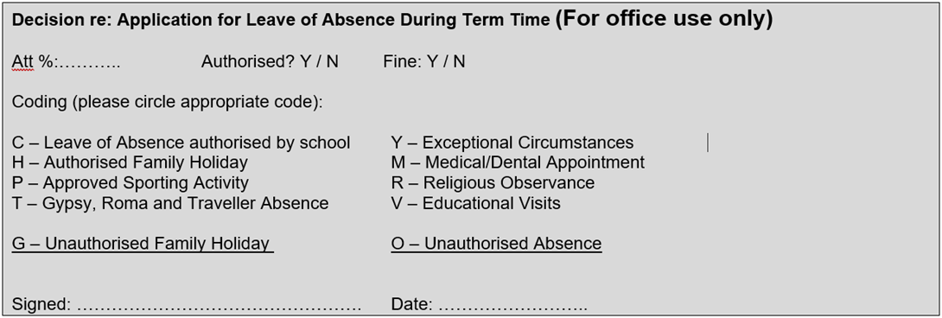

**X** Code – The codes above do not apply if your child is under 5 years old as they have not reached Statutory School age yet.