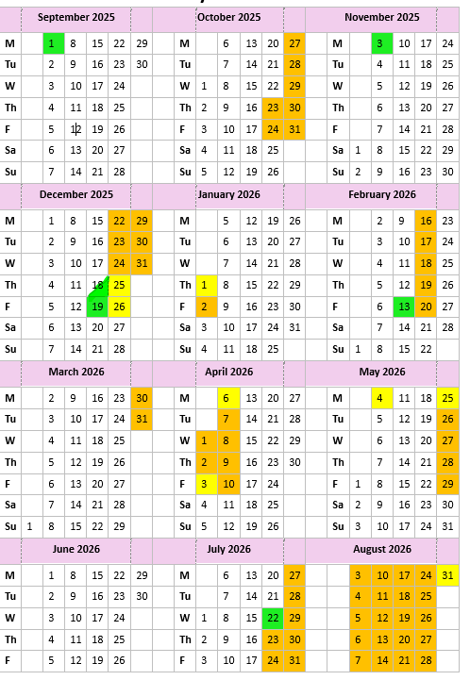
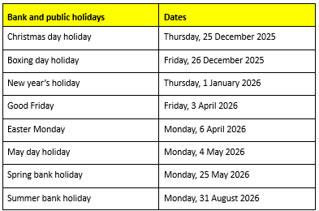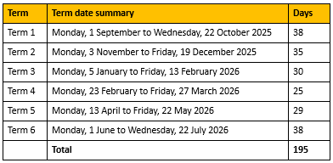
INSET DAYS | Monday 1st September 2025
 | Monday 3rd November 2025
 | Thursday 18th December 2025 – Finish at 1:30pm
 | Friday 19th December 2025
 | Friday 13th February 2025
 | Wednesday 22nd July 2025

